Working Concept Of This Model
PROJECT DOCUMENTATION
Title:
Smart Product Recommendation System using Collaborative Filtering
1. INTRODUCTION
A Recommendation System is a data-driven application that suggests items (products, movies, music) to users based on their preferences and past behavior.
It is widely used in platforms like:
- E-commerce (Amazon)
- Streaming (Netflix, Spotify)
- Social Media (YouTube)

2. OBJECTIVE
- To analyze user behavior (ratings)
- To predict user preferences
- To recommend relevant items
3. WORKING PRINCIPLE
This project uses Collaborative Filtering, which works on:
👉 “Users with similar behavior will like similar items”

4. SYSTEM WORKFLOW
Step-by-Step Flow
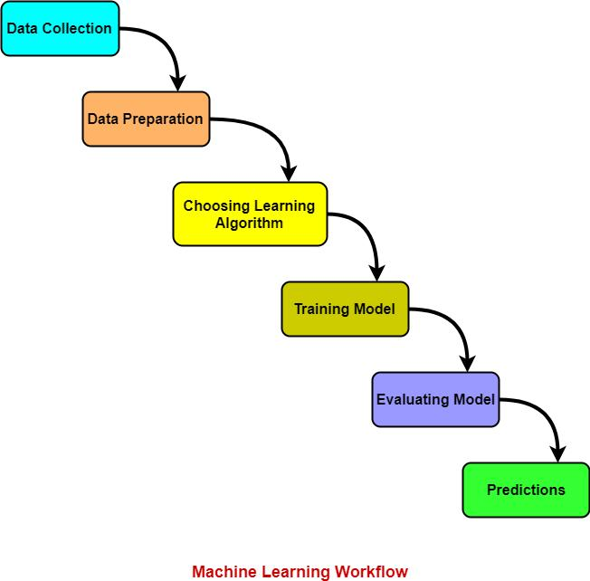
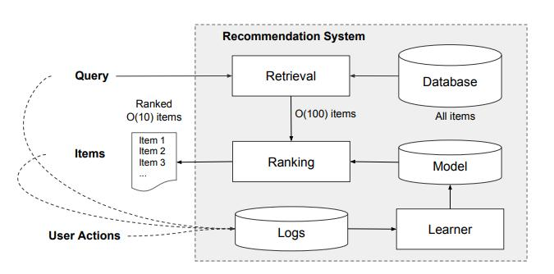
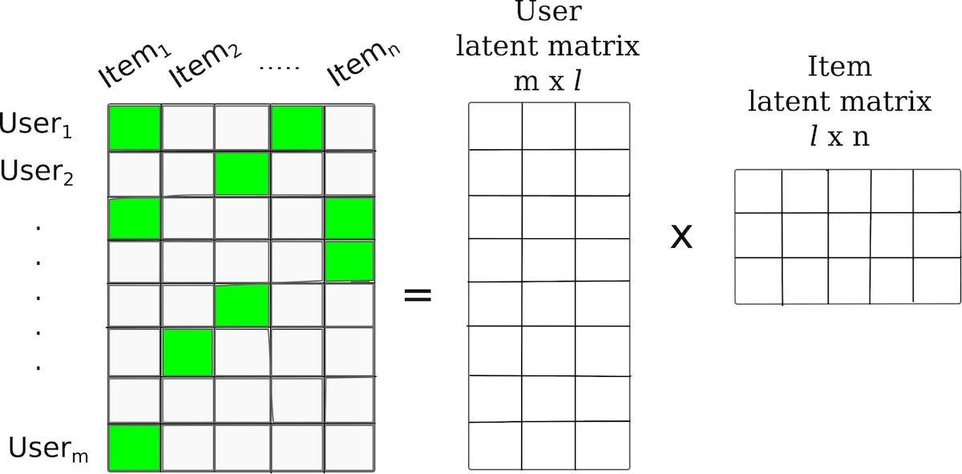
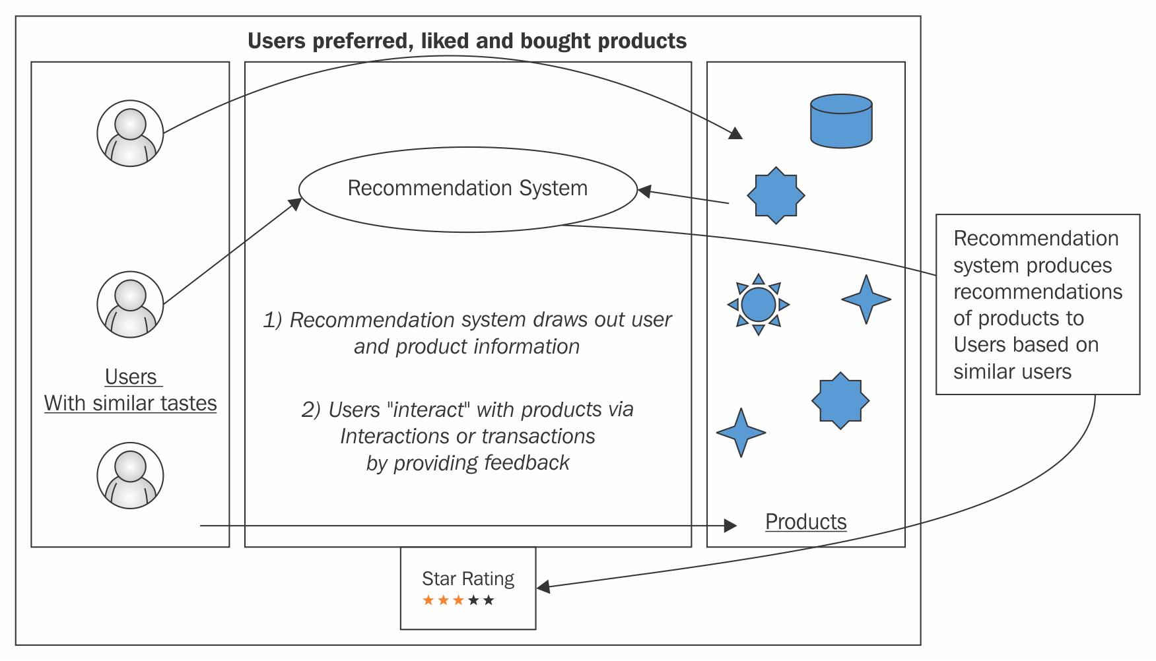
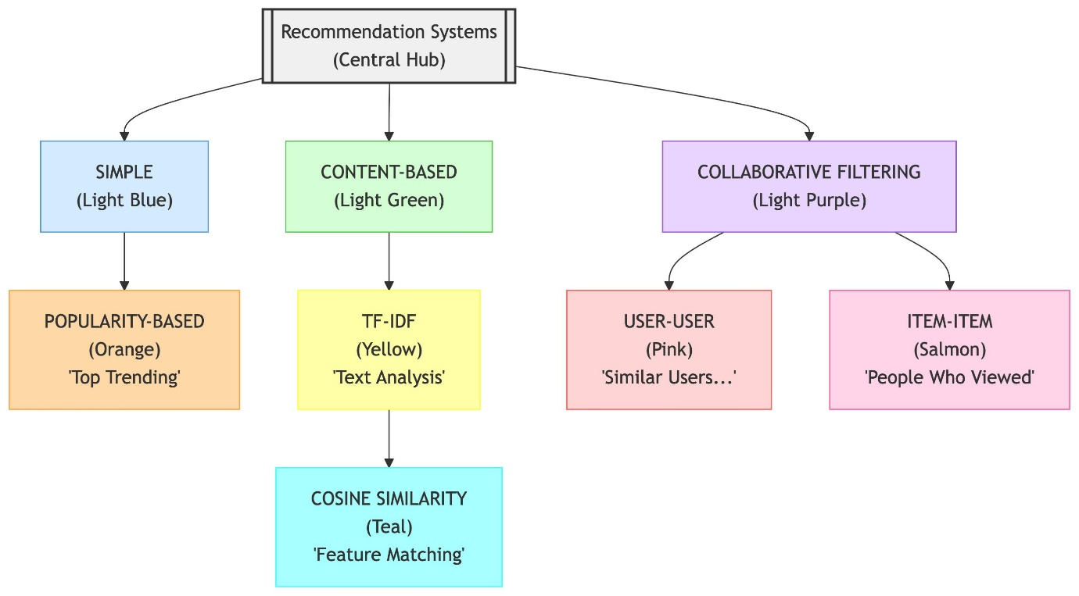
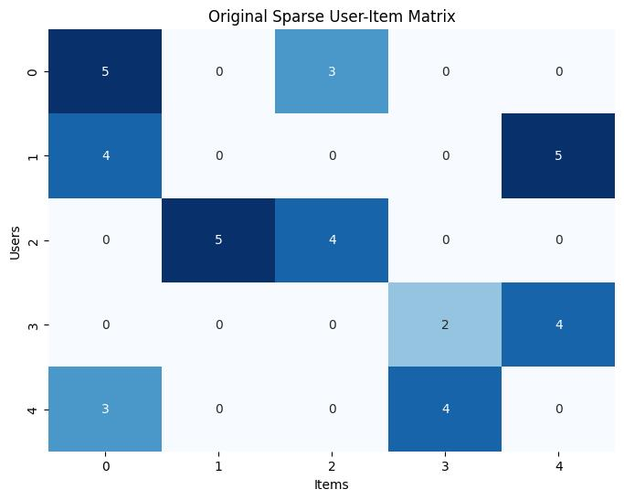
🔹 Steps Explanation:
- Data Collection
  - UserId, ItemId, Rating collected
- Data Preprocessing
  - Clean missing values
  - Format dataset
- User-Item Matrix Creation
  - Rows → Users
  - Columns → Items
  - Values → Ratings
- Model Training (SVD)
  - Learns hidden patterns (latent features)
- Prediction
  - Predict unknown ratings
- Recommendation
  - Suggest top-rated items

5. MATHEMATICAL CONCEPT (CORE IDEA)
The model predicts rating using:
\hat{r}_{ui} = \mu + b_u + b_i + q_i^T p_u
Where:
- ( \hat{r}_{ui} ) = predicted rating
- ( \mu ) = global average
- ( b_u ) = user bias
- ( b_i ) = item bias
- ( p_u, q_i ) = latent factors
👉 This is used in SVD (Matrix Factorization
6. SYSTEM ARCHITECTURE

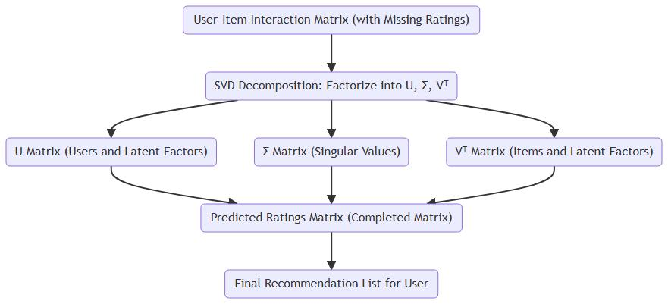
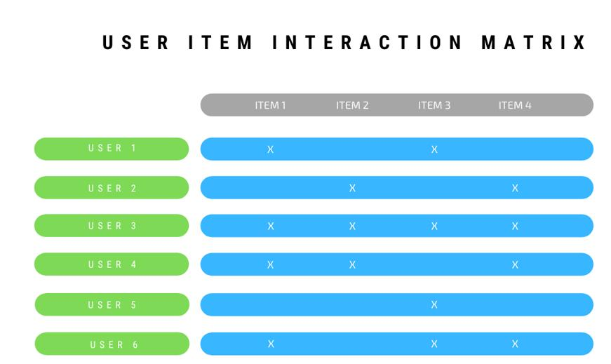
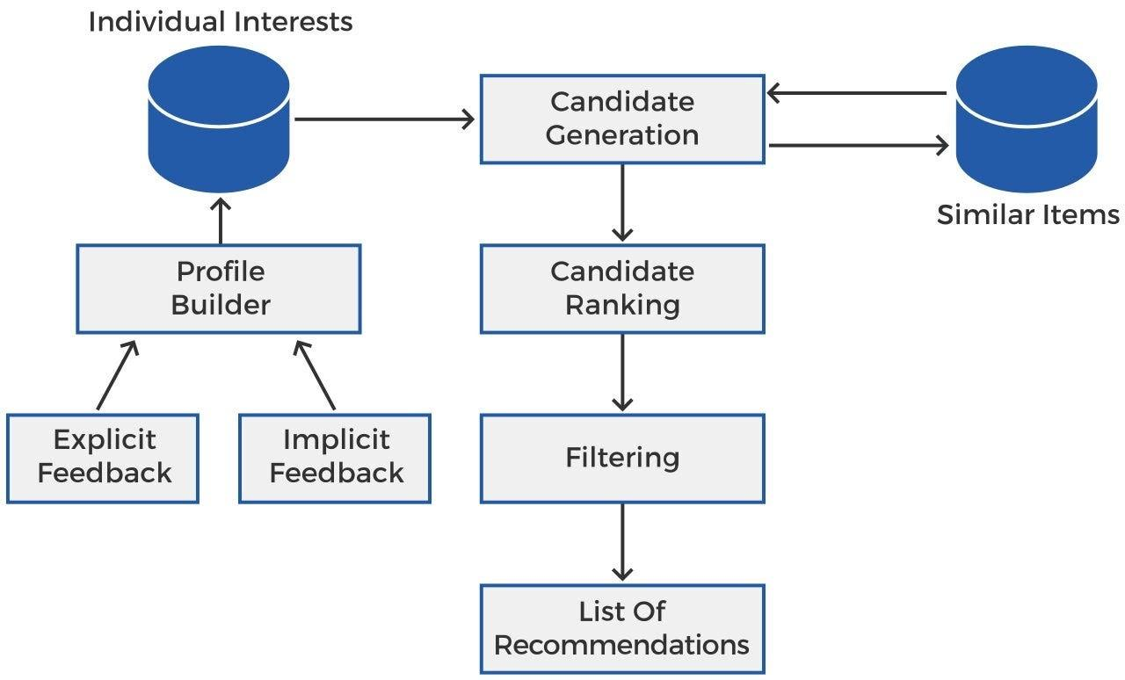
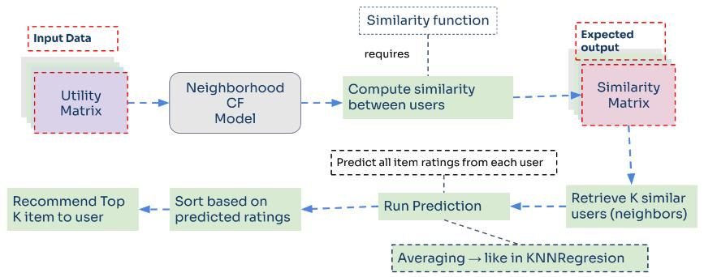
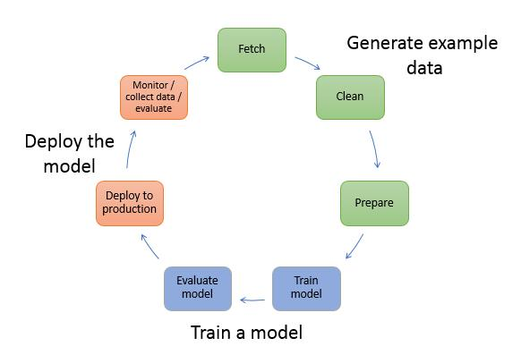
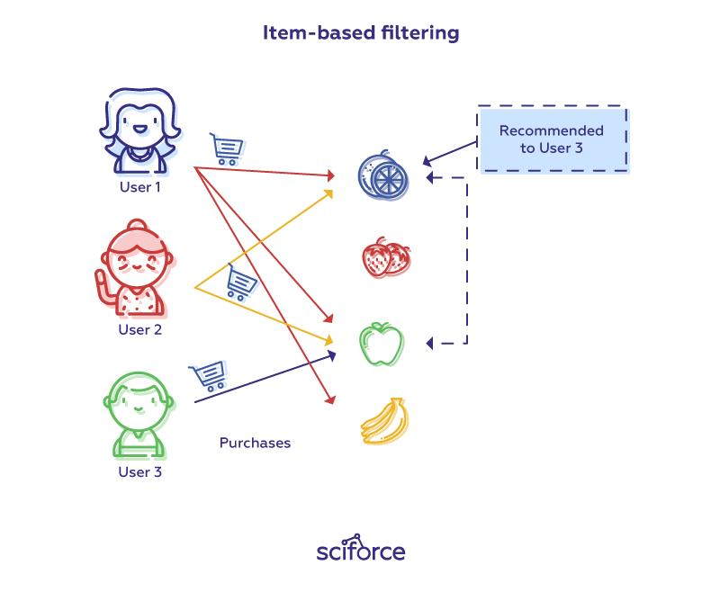
🔹 Components:
- Input Layer → Dataset
- Processing Layer → Model Training
- Output Layer → Recommendations

💻 7. IMPLEMENTATION (SCRIPTED EXPLANATION)
🔹 Step 1: Import Libraries
import pandas as pd
from surprise import Dataset, Reader, SVD
🔹 Step 2: Load Dataset
df = pd.read_csv("ratings.csv")
🔹 Step 3: Convert to Surprise Format
reader = Reader(rating_scale=(1,5))
data = Dataset.load_from_df(df[['userId','itemId','rating']], reader)
🔹 Step 4: Train Model
model = SVD()
model.fit(trainset)
🔹 Step 5: Predict Rating
model.predict(user_id, item_id)
8. INPUT & OUTPUT
📥 Input:
userId | itemId | rating
1 | 101 | 4
📤 Output:
Predicted Rating: 4.6
Recommended Items: [102, 105, 110]

9. ADVANTAGES
- Personalized recommendations
- Improves user experience
- Increases sales/engagement

10. LIMITATIONS
- Cold start problem
- Sparse data issue
- Requires large dataset

11. REAL-WORLD APPLICATIONS
- Amazon → Product suggestions
- Netflix → Movie recommendations
- Spotify → Music playlists

12. FUTURE ENHANCEMENT
- Hybrid recommendation system
- Deep learning models
- Real-time recommendations

13. CONCLUSION
This project successfully demonstrates how machine learning can be used to build intelligent recommendation systems using collaborative filtering techniques like SVD.

